

**Product Dissection of UBS**

**Company Overview:**

UBS works with individuals, families, institutions, and corporations around the world to help answer some of life's questions – whether through award winning wealth management advisory, investment banking and asset management expertise, or private and corporate banking services in Switzerland*. In June 2023, Credit Suisse became a UBS Group company. With a large and diverse team operating internationally, UBS has a presence in all major financial centers in more than 50 countries.

UBS provides wealth management, asset management, and investment banking services for private, corporate, and institutional clients with international service. UBS manages the largest amount of private wealth in the world, counting approximately half of The World’s Billionaire among its clients. UBS also maintains a global investment bank and is considered a primary market maker.

**Product Dissection and Real-World Problems Solved by UBS:**

UBS Group AG is a multinational [investment bank](https://en.wikipedia.org/wiki/Investment_banking) and [financial services](https://en.wikipedia.org/wiki/Financial_services) company founded and based in [Switzerland](https://en.wikipedia.org/wiki/Switzerland). Headquartered in [Zürich](https://en.wikipedia.org/wiki/Z%C3%BCrich), it maintains a presence in all major financial centres as the [largest Swiss banking institution](https://en.wikipedia.org/wiki/List_of_largest_banks) and the [largest private bank](https://en.wikipedia.org/wiki/Private_banking) in the world. UBS client services are known for their strict bank–client confidentiality and culture of [banking secrecy](https://en.wikipedia.org/wiki/UBS#Banking_secrecy). Because of the bank's large positions in the [Americas](https://en.wikipedia.org/wiki/Americas), [EMEA](https://en.wikipedia.org/wiki/Europe,_the_Middle_East_and_Africa), and [Asia Pacific](https://en.wikipedia.org/wiki/Asia-Pacific) markets, the [Financial Stability Board](https://en.wikipedia.org/wiki/Financial_Stability_Board) considers it a global systemically important bank.

UBS's global [wealth management](https://en.wikipedia.org/wiki/Wealth_management) advisory division offers [high-net-worth individuals](https://en.wikipedia.org/wiki/High-net-worth_individual) around the world a range of advisory and [investment products](https://en.wikipedia.org/wiki/Investment_products) and services. It is a comprehensive financial advisory service that involves the coordination of various financial activities to help individuals and families manage, grow, and preserve their wealth and solve problems such as life and family planning, risk management, tax planning etc.  
UBS asset management division provides investment portfolio management with access to international markets, well researched and compliant investment capabilities solve the problem of the consumer to grow and preserve value of assets as per risk tolerance of the client.

The investment banking division with its capital raising, financial service, advisory, research and trading etc. from corporations seeking strategic advice or an institutional investor looking for trading solutions offering a broad spectrum of services to meet unique needs of the clients.   
Personal and Corporate banking

Personal and Corporate banking offers banking services, including savings and checking accounts, debit cards, and online/mobile banking. Customized credit and lending solutions to meet unique financial requirements. Business checking and savings accounts with flexible features to meet the unique needs of businesses. Comprehensive commercial lending solutions, including term loans, working capital financing, and lines of credit, etc.

**Case Study: Real-World Problems and UBS approach to solutions**

UBS was founded in 1862 as the [Bank in Winterthur](https://en.wikipedia.org/wiki/Bank_in_Winterthur). With the continuous mergers and acquisitions UBS has expanded its reach into new financial domains, have solved complex financial problems by identifying and satisfying dynamic needs of the customers with confidence, security and discretion as being represented by the company logo of 3 keys.

1. **Uncertainty of life and Wealth management**

**Real World Challenge**: In the continuously changing environment and uncertain aspects of life, the challenge of safe, secure and smooth wealth management has been a major problem of HNIs and their families.

**UBS Solution**: Helping wealthy individuals and families pursue what matters most to them has been the purpose for over 160 years. The expertise and knowledge inhibited by the company is the driving force for providing top notch services for investment management, life and family planning, business and financial planning, Risk Management, Estate Planning and Tax planning, other banking facilities to help clients grow, protect, and distribute their wealth over time, considering their financial goals and individual circumstances.

1. **Challenges and Risks with the Investment portfolio management**

**Real World Challenge**: Access to investment capabilities and investment styles across various regions in line with regulatory compliance.

Performing research and analysis to manage, grow and preserve the value of the assets as per the specific financial objectives and risk tolerances is a challenge to the individuals, institutes and corporations.

**UBS Solution**: UBS being the leading fund house in Europe, the largest mutual fund manager in Switzerland and the top foreign firm in China.

Asset Management is a large-scale and diversified asset manager, with a presence in 22 countries. UBS offers investment capabilities and investment styles across all major traditional and alternative asset classes, as well as platform solutions and advisory support to institutions and wealth management clients. The solid foundation of UBS investment strategy and position provides assurance to the client for the well planned, sustainable and secured investment portfolio management with utmost trusted, client-oriented and diversified formulated services.

1. **Unsatisfactory and complicated banking services**

**Real World Problem**: Banks having services that are not up to the requirements of the client and are often very time consuming and less flexible, with limited consideration for future prospects and needs of the client in a changing environment.

**UBS Solution**: UBS providing all round Personal & Corporate Banking comprehensive financial products and services to private, corporate and institutional clients in Switzerland*, maintaining a leading position in these segments and embedding its offering in a multi-channel approach.

The business supports other business divisions by referring clients and growing the wealth of the firm’s private clients so they can be transferred to Wealth Management. Personal & Corporate Banking leverages the cross-selling potential of UBS’s asset-gathering and investment banking products. The vast business footprint of UBS provides clients to upgrade and customize their requirements to grow their value.

1. **Limited knowledge and reach to International Capital market**

**Real World Problem:** The corporate, institutional and wealth management clients suffer with different problems related to Capital raising, valuation and advisory, research and trading, mergers and acquisition, credit financing and risk management and other specific requirements that need to be addressed on an occasional basis. The expertise, sustainability and execution required to fulfil these necessities comes out to be a major issue for the clients.

**UBS Solution**: UBS Investment Bank provides corporate, institutional and wealth management clients with expert advice, innovative solutions, execution and comprehensive access to international capital markets.

UBS provides services to corporations for raising capital but also for the financial institutions, HNIs wealth managers to invest into the companies in overseas markets including sales, trading and market-making across a range of securities with a smooth execution and professional endeavour, hence is also called the primary market maker.

**Conclusion:**

UBS is a multinational [investment bank](https://en.wikipedia.org/wiki/Investment_banking) and [financial services](https://en.wikipedia.org/wiki/Financial_services) company having a vast experience and knowledge in the financing domain, with its strict bank–client confidentiality and culture of [banking secrecy](https://en.wikipedia.org/wiki/UBS#Banking_secrecy) have created its position as a top private bank and leading wealth management service provider attracting and solving problems of HNIs around half of the world’s Billionaire.

Along the journey of asset management, it has accessed various financial markets and compliance regulations providing investment planning, research and analysis, risk management and continuous monitoring with communication of investment activities to the client for better and sustainable returns. Research and investment portfolio management provides a solid foundation for providing investment banking services as well, not only to corporations for raising capital but also for the financial institutions, HNIs wealth managers to invest into the companies in overseas markets including sales, trading and market-making across a range of securities.

UBS has leveraged and enhanced its services by cross selling with personal and corporate financing, bringing value creation and growing of client wealth and then encouraging asset-gathering and investment banking products.

With the continuous changing environment and requirements of different clients UBS has evolved itself for providing diversified and sustainable financing solutions.

**Top Facilities and Services of UBS:**

1. **Wealth Management**UBS has been helping wealthy individuals and families pursue what matters most to them has been the purpose for over 160 years. Wealth management is a comprehensive financial advisory service that involves the coordination of various financial activities to help individuals and families manage, grow, and preserve their wealth. The wealth management services include but not limited to services such as:

* **Risk Management**

Risk management helps to identify, assess, and mitigate potential risks associated with your financial portfolio. It consists of giving a thorough analysis of the financial situation to identify various types of risks. Evaluate risk tolerance, financial goals, and time horizon to tailor a risk management strategy that aligns with the client's unique circumstances.

* **Insurance Planning**

Insurance planning of the HNIs and families is the subdivision of the wealth management that evaluates and provides recommendations on the appropriate mix of insurance products to address identified risks, insurance coverage including life, health, property, and liability insurance. Integrate insurance products as a crucial component to wealth management strategy to safeguard client assets.

* **Tax Planning**

Tax planning with respect to wealth management refers to optimizing the financial strategy by minimizing tax liabilities and maximizing after-tax returns for the clients, including comprehensive analysis of the financial situation to identify potential tax implications and areas for tax optimization and the placement of assets across various account types (taxable, tax-deferred, and tax-free) to enhance tax efficiency etc.

1. **Asset Management**Asset Management services of UBS plays a role to help strategically manage and grow the investments to achieve client’s financial goals. Being a part of the wealth management services the access to investment capabilities and investment styles of asset management division has extended its client base to individuals, institutes and corporations. Utilizing a range of asset classes, including equities, fixed income, alternatives, and cash, to build a well-balanced and diversified investment portfolio. Leveraging UBS's research capabilities and expertise to make informed investment decisions. Offering sustainable and responsible investment options such as environmental, social, and governance (ESG) factors into the investment process when constructing portfolios.
2. **Investment Banking**

Investment Banking Provide strategic advisory services for mergers and acquisitions (M&A), facilitate capital raising activities through public offerings (IPOs). It provides international perspectives and access to a broad range of capital markets. Offer insights and strategies based on a deep understanding of market dynamics in various industries. Assist clients in optimizing their capital structure and financing through capital raising and debt to enhance shareholder value. With the help of the investment banking division UBS can enhance its customer base and services by combining the asset management clients and giving all round support to the clients on both sides.

1. **Corporate Banking**Business checking and savings accounts with upgradable features to meet the unique needs of businesses. Comprehensive commercial lending solutions, including term loans and lines of credit. Cutting-edge digital banking platforms for corporate clients, facilitating efficient financial management and reporting.
2. **Personal Banking**Everyday banking services, including savings and checking accounts, debit cards, and online/mobile banking, loans and financing etc. Exclusive banking services for high-net-worth individuals, including personalized financial solutions and access to a dedicated team of wealth management professionals.

**Entities:**

1. **Client**

* ClientID (Primary Key): Unique identifier for each client.
* FirstName: First name of the client.
* LastName: Last name of the client.
* Address: Address of the client.
* ContactDetails: Contact details of the client.
* AccountType: Type of account (e.g., individual, corporate).

1. **Personal Banking**

* PersonalBankingID (Primary Key): Unique identifier for each personal banking account.
* ClientID (Foreign Key): References the Client table, linking to the corresponding client.
* AccountNumber: Account number for the personal banking account.
* Balance: Current balance in the personal banking account.
* CreditScore: Credit score associated with the client.

1. **Corporate Banking**

* CorporateBankingID (Primary Key): Unique identifier for each corporate banking account.
* ClientID (Foreign Key): References the Client table, linking to the corresponding client.
* CompanyName: Name of the corporate entity.
* Industry: Industry to which the corporate client belongs.
* Revenue: Revenue generated by the corporate client.

1. **Wealth Management**

* WMID (Primary Key): Unique identifier for each wealth management account.
* ClientID (Foreign Key): References the Client table, linking to the corresponding client.
* PortfolioValue: Value of the client's investment portfolio.
* RiskAppetite: Client's risk tolerance.
* FinancialGoals: Goals related to financial planning.
* InvestmentHorizon: Duration over which the client plans to invest.
* AdvisoryTeam: Team providing advisory services.

1. **Risk Management**

* RiskID (Primary Key): Unique identifier for each risk management entry.
* WMID (Foreign Key): References the WealthManagement table, linking to the corresponding wealth management account.
* RiskType: Type of risk being managed.
* RiskLevel: Level or severity of the identified risk.

1. **Insurance Planning**

* InsuranceID (Primary Key): Unique identifier for each insurance planning entry.
* WMID (Foreign Key): References the WealthManagement table, linking to the corresponding wealth management account.
* InsuranceType: Type of insurance being planned.
* CoverageAmount: Amount of coverage planned for the insurance.

1. **Tax Planning**

* TaxID (Primary Key): Unique identifier for each tax planning entry.
* WMID (Foreign Key): References the WealthManagement table, linking to the corresponding wealth management account.
* TaxStrategy: Strategy for tax planning.
* TaxAdvisors: Advisors involved in tax planning.

1. **Asset Management**

* AMID (Primary Key): Unique identifier for each asset management account.
* ClientID (Foreign Key): References the Client table, linking to the corresponding client.
* InvestmentPortfolio: Description of the client's investment portfolio.
* FundPerformance: Performance details of investment funds.
* AssetAllocation: Allocation of assets in the investment portfolio
* AssetManager_id: This is the bank integral asset manager id each manager can manage many client assets at a time.

1. **Investment Banking**

* IBID (Primary Key): Unique identifier for each investment banking account.
* ClientID (Foreign Key): References the Client table, linking to the corresponding client.
* IPOsManaged: Number of Initial Public Offerings managed by the investment banking division.
* MAndATransactions: Number of mergers and acquisitions transactions managed.
* CapitalRaising: Amount of capital raised
* AssetManager_id: This is the bank integral asset manager id that buys or sells assets through the bank's investment banking division.

1. **Investment**

* InvestmentID (Primary Key): Unique identifier for each investment.
* ClientID (Foreign Key): References the Client table, linking to the corresponding client.
* WMID (Foreign Key): References the WealthManagement table, linking to the corresponding wealth management account.
* AMID (Foreign Key): References the AssetManagement table, linking to the corresponding asset management account.
* IBID (Foreign Key): References the InvestmentBanking table, linking to the corresponding investment banking account.
* InvestmentType: Type of investment.
* InvestmentAmount: Amount invested.
* Date: Date of the investment.

**Relationships:**

1. **Client - Personal Banking (1: Many):**

* One client can have multiple personal banking accounts like saving, current or fixed.
* PersonalBanking references Client using ClientID as a foreign key.

1. **Client - Corporate Banking (1: Many):**

* One client can have multiple corporate banking accounts.
* CorporateBanking references Client using ClientID as a foreign key.

1. **Client - Wealth Management (1:1):**

* One client can have one wealth management account.
* WealthManagement references Client using ClientID as a foreign key.

1. **Wealth Management - Risk Management (1: Many):**

* One wealth management account can have multiple risk management entries.
* RiskManagement references WealthManagement using WMID as a foreign key.

1. **Wealth Management - Insurance Planning (1: Many):**

* One wealth management account can have multiple insurance planning entries.
* InsurancePlanning references WealthManagement using WMID as a foreign key.

1. **Wealth Management - Tax Planning (1: Many):**

* One wealth management account can have multiple tax planning entries.
* TaxPlanning references WealthManagement using WMID as a foreign key.

1. **Client - Asset Management (1: Many):**

* One client can have multiple asset management accounts.
* AssetManagement references Client using ClientID as a foreign key.

1. **Client - Investment Banking (1: 1):**

* One client can have one investment banking account.
* InvestmentBanking references Client using ClientID as a foreign key.

1. **Wealth Management - Investment (1: Many):**

* One wealth management account can have multiple investments.
* Investment references WealthManagement using WMID as a foreign key.

1. **Asset Management - Investment (1: Many):**

* One asset management account can have multiple investments.
* Investment references AssetManagement using AMID as a foreign key.

1. **Investment Banking - Investment (1: Many):**

* One investment banking account can have multiple investments.
* Investment references InvestmentBanking using IBID as a foreign key.

**ER Diagram:**Let’s construct an ER diagram for schema design of UBS with our approach, this would be an estimated schema model for UBS that highlights relationships and attributes of the entities. This would be showing the major features or facilities being provided by UBS to its clients. The core business divisions and sub divisions have been shown in the diagram along with the relationships between them determining the data flows and giving an understanding of the data architecture framework of the UBS.

**UBS ER Diagram**

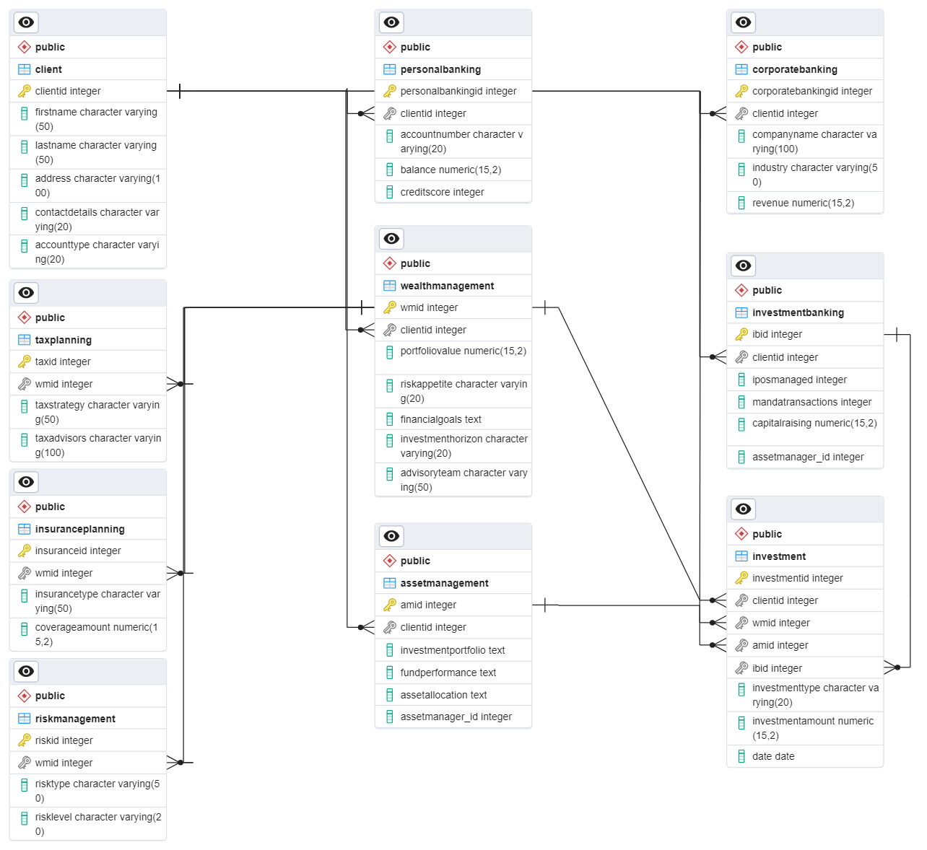

**Conclusion:**In this case study we delved into UBS and analysed its core business and services being provided by the bank, that solves the financial problems faced by various clients ranging from HNIs, Corporations, institutions etc. UBS has been a well-established financial service provider in the domain of wealth management, asset management, investment banking and personal and corporate banking.

We have made an estimated Entity – Relationship diagram, making the business divisions of the company as entities and relationships as the way data is segregated and managed. It has provided understanding of the data model design on how the data can be stored and the relationships between the business division and sub division can be formulated, in order to manage and solve complex data related requirements.